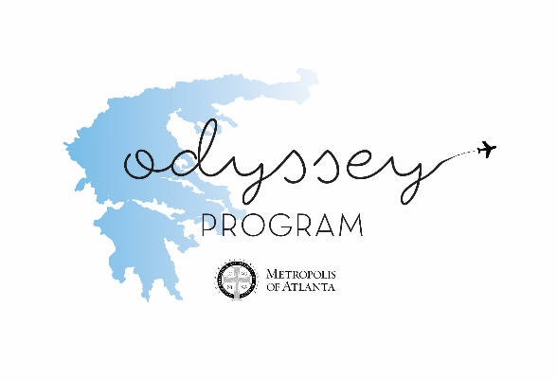
Odyssey Travel Program
Dancer Information
Summer 2018
#SpreadtheWord!!

In order for Youth & Young Adults to gain a deeper appreciation for, and immersion in, our rich Hellenic Culture, the Hellenic Dance Festival Committee, in cooperation with the Metropolis of Atlanta, will sponsor a trip to Greece for eligible individuals at least once every four years. Participants will travel as a group and participate in Dance Workshops, Performances, Village Panagyris, and various Cultural & Historical Sites. The 12-day trip will allow interested teens an opportunity to experience Greece as a local.

Here’s what you need to know in order to apply!

- All interested applicants must attend an Odyssey Travel Meeting on Sunday, January 15th from 3:00pm – 4:00pm during the 2017 HDF Weekend in Winston-Salem. Final details of the trip will be discussed & released during this time. There will also be a question and answer session for applicants and their parents.

- Applicants should be an active, sacramental member of a parish within the Metropolis of Atlanta. They (or their parents in the case of a minor) should be stewards of their parish.

- The ideal candidate for the Dancer Scholarship is between 15-19 years old and has completed at least one-year of High School. Individuals outside of this age group are still welcome to apply.

- Students still in High School should be active in their parish based GOYA and Catechetical School. Preference will be given to youth who participate in more than one metropolis or district sponsored event in addition to the HDF Weekend.

- All applicants must have performed with their parish based dance group in at least three of the HDF Weekends since 2014.

- All applicants are required to fulfill 60 volunteers hours of service to their local parish beginning February 2017. A detailed outline of these hours, signed by the parish priest, applicant, and parent or guardian of those under 18, must be submitted by November 30th.

- Two signed and sealed letters of recommendation are considered part of the application— one from the local parish priest and one from a teacher, professor, or youth worker who can speak to the qualifications, maturity and faithfulness of the applicant. Dance Directors should not provide a recommendation letter, but will be asked to submit an online evaluation regarding the applicant’s adaptability, initiative, focus, team spirit, and talent. All recommendations are confidential.

- Submit a 300 word essay indicating why you should be selected, your current experience with Greek culture and dance, how you intend to use the knowledge you gain from the trip to further educate others in your parish or the Metropolis at large

- Applicants are required to submit a 5-7 minute video on an approved topic, expressing their knowledge of the subject in a creative way.

- Only fully completed applications submitted prior to the deadline will be considered.

- An independent panel of judges will review all scholarship applications and submissions. Judges, selected by the Metropolis of Atlanta, will be Orthodox Christians with an understanding of our heritage, faith, and youth of today. The Metropolis of Atlanta will award all scholarship monies.

- Previous Odyssey Scholarship winners are not eligible to apply

Additional Information

A total of 15 dancers will be awarded Odyssey Scholarships. Thirteen dancers will receive a 100% land based scholarship (this scholarship does not include airfare to and from Athens). The top two winners will receive a land based scholarship, and roundtrip airfare from New York to Athens.

Limited air travel scholarships, based upon financial need, are also available. Once you have been selected to receive an Odyssey Scholarship, winners can contact the Metropolis of Atlanta directly regarding additional financial assistance for travel.

When there are multiple candidates who meet all of the criteria and are equal in talent, preference will be given to those who have never traveled to Greece or have traveled less than three times in the past 10 years (this allows our youth who otherwise would not have an opportunity to visit Greece to gain valuable experience with our heritage & culture)

In order to expand the knowledge base throughout our Metropolis, we will make every effort to include winners from all of our conferences. Based upon the total number of applicants, we may limit the number of scholarships to a maximum of two dancers from any one parish.

Travel Itinerary will be finalized by January 31, 2018.

