Join us for a truly unique travel opportunity - experience Greece from a spiritual and cultural perspective. Winners will be visiting historical sites, monasteries and churches, taking classes from experts, and performing in some of the most beautiful cities in Greece.

DANCE ODYSSEY 2018
OBJECTIVES

- To further cultivate an appreciation for our Hellenic culture and rich Orthodox faith and tradition.
- To inspire our young people to value and contribute to cultural opportunities at home.
- To create a greater awareness of our world and the various peoples who inhabit it.
- To allow young people who have invested time into their parish and faith an opportunity to experience Greek culture up close.
- To provide dancers an opportunity to participate in workshops from local Greek dance experts
- To give dancers the opportunity to perform in Greece and experience the local dance culture.
- To give deserving Hellenic Dancers the opportunity to experience traditional Greek folk dance in its natural setting
- To instill in our young people the importance of our traditional Hellenic heritage and Orthodox Faith.

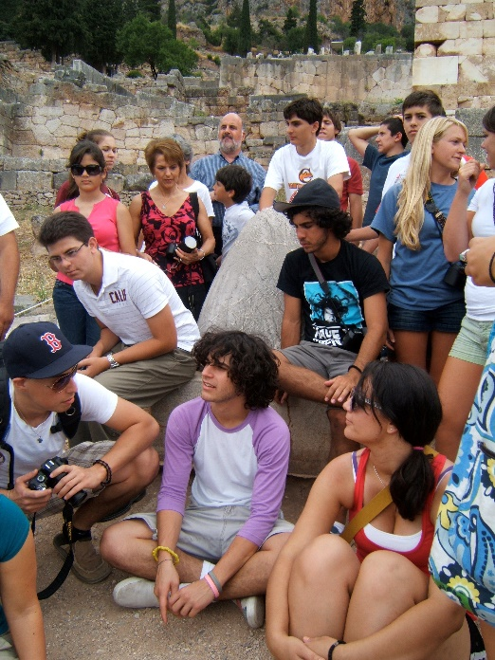
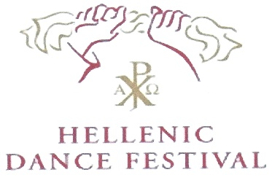
Above all, scholarship applicants must be dedicated to the ideals and mission of the Hellenic Dance Festival and willing to be active participants in their local parishes, as well as metropolis sponsored workshops, HDF weekends, or committees, following their trip.

The experience and knowledge gained as an Odyssey Scholarship Winner is to be shared with all participants of the HDF program and not for the personal benefit of the individual. Scholarship recipients are a vital link to the growth and future of HDF.

We kindly ask only those individuals who believe they can successfully contribute to HDF in the future to submit an application

